Lab 7
OSPF
Objective:
The purpose of this lab is for the student to understand, create and implement OSPF. Students will also utilize IOS commands to explore and configure OSPF on network routers and switches.
Diagram:
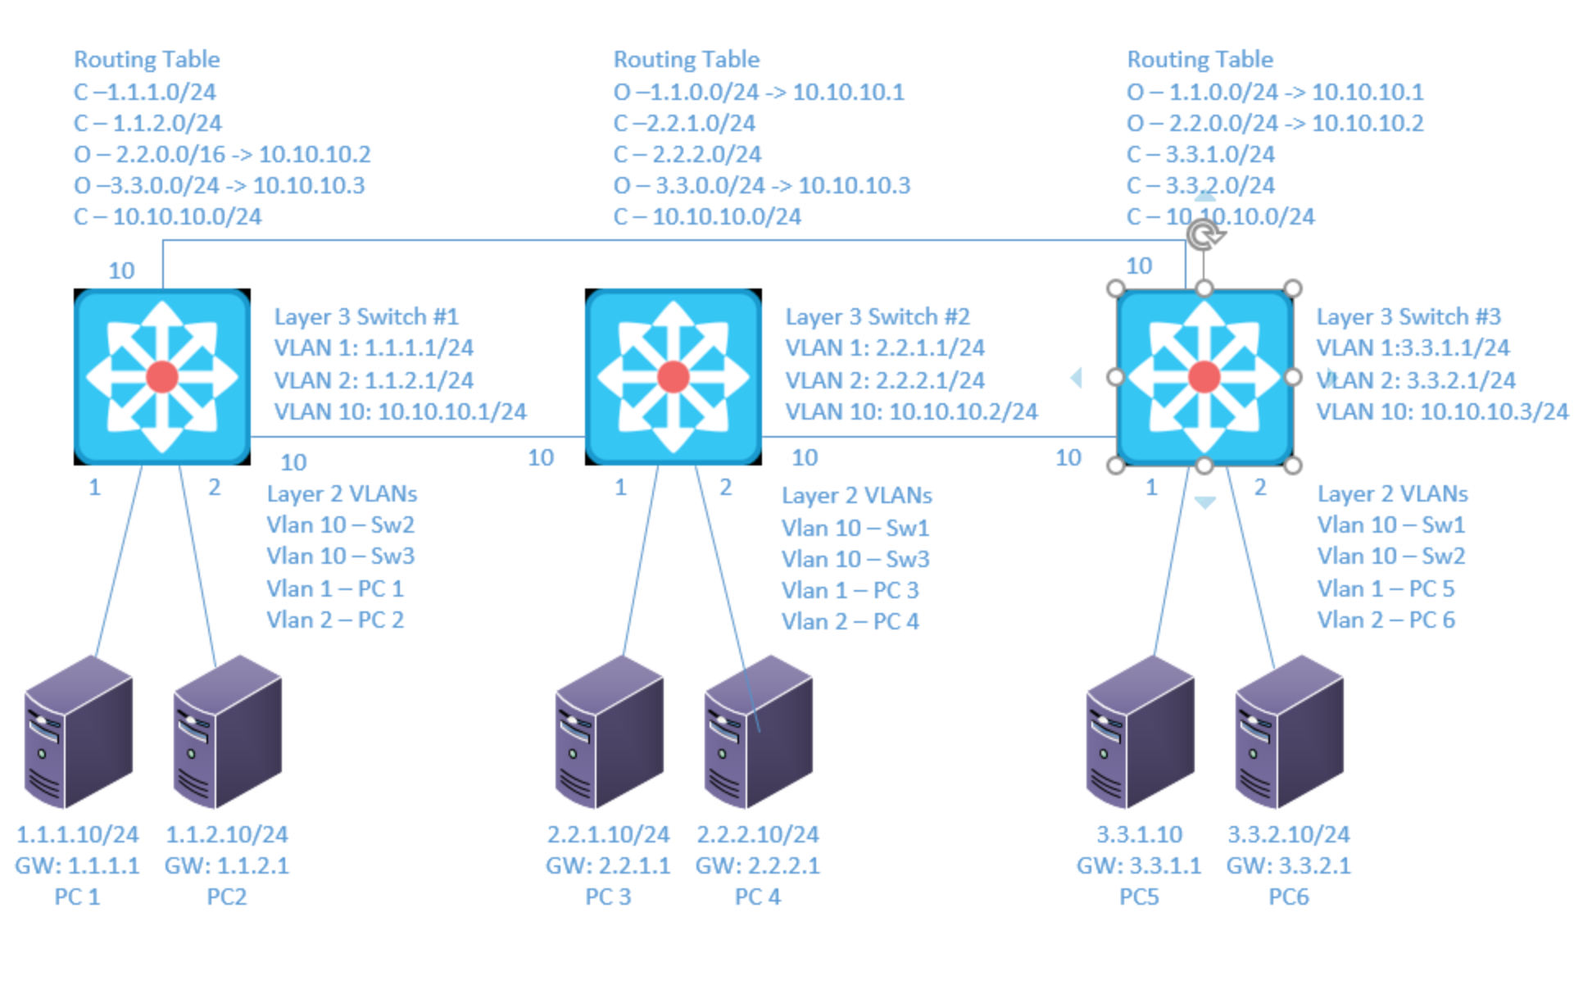
Components:
6 – PC’s with an Ethernet NIC
3 – Cisco 3650 Layer 3 Switches

Useful commands for this lab:

show ip route – view routing table
show ip interface brief - view brief list of interfaces
show vlan – view vlan database

Configure Basic OSPF

router ospf 1 (creates ospf routing (process id of 1))
network 10.10.10.0 0.0.0.255 area 0 (turns on ospf for interfaces that start with 10.10.10 and places it in area 0)
passive-interface default (places all ospf interfaces in passive mode)
no passive-interface vlan10 (removes vlan 10 from being a passive interface)
passive-interface vlan5(makes vlan 5 a passive interface)
router-id 10.10.10.1 (gives the ospf process an ID of 10.10.10.1

OSPF Show
show ip ospf interface – Shows if authentication is enabled and type
show ip ospf interface interface – lists process id, router id, network type, cost
show ip ospf interface brief – lists ospf enabled interfaces (omits passive interfaces)
show ip protocols – lists the network configuration commands for each routing process
show ip ospf neighbors – Lists known neighbors and state
show ip ospf database – lists all LSA’s for all connected areas
show ip route – displays routing table

OSPF Authentication
interface vlan10
ip ospf authentication (cleartext)
Switch(conf-if)#ip ospf authentication-key secretkey
Switch(conf-if)#ip ospf authentication message-digest (secure)
Switch(conf-if)#ip ospf message-digest-key 1 md5 secretkey

Or

router ospf 1
area 0 authentication message-digest
Interface vlan10
ip ospf message-digest-key 1 md5 secretkey

Route Summarization

For ABR
router ospf 1
area 1 range 1.1.0.0 255.255.0.0 (the area is what area the routes are in)

For ASBR
router ospf 1
summary-address 1.1.0.0 255.255.0.0
Procedure:
- Connect all PC’s together and put their static IP addresses, subnet masks and gateways on them. Test connectivity by pinging each machine within the network.

- Label the Layer 3 switches VLAN IP addresses below
Switch 1
VLAN | IP Address | Port
1 | 1.1.1.1/24 | 1
2 | 1.1.2.1/24 | 2
10 | 10.10.10.1/24 | 10, 11

Switch 2
VLAN | IP Address | Port
1 | 2.2.1.1/24 | 1
2 | 2.2.2.1/24 | 2
10 | 10.10.10.2/24 | 10, 11

Switch 3
VLAN | IP Address | Port
1 | 3.3.1.1/24 | 1
2 | 3.3.2.1/24 | 2
10 | 10.10.10.3/24 | 10, 11

- Label the routing tables for the Layer 3 switch and routers below.

Switch 1 | Switch 2 | Switch 3
C-1.1.1.0/24 | C-2.2.1.0/24 | C-3.3.1.0/24
C-1.1.2.0/24 | C-2.2.2.0/24 | C-3.3.2.0/24
C-10.10.10.0/24 | C-10.10.10.0/24 | C-10.10.10.0/24
O-2.2.0.0/16->10.10.10.2 | O-1.1.0.0/16->10.10.10.1 | O-1.1.0.0/16->10.10.10.1
O-3.3.0.0/16->10.10.10.3 | O-3.3.0.0/16->10.10.10.3 | O-2.2.0.0/16->10.10.10.2

- Place the switch ports into the proper vlans. Configure all of the switches vlan IP addresses.

- Enable routing on the Layer 3 switches

- On switch 1 enable router OSPF as follows:
  - Make the process ID of 1
    - What command did you enter
Router ospf 1
  - Set the router ID to be 10.10.10.1
    - What command did you enter
Router-id 10.10.10.1
  - Place 10.10.10.0/24 in area 0
    - What command did you enter
Network 10.10.10.0 0.0.0.255 area 0
  - Place the other directly connected networks in area 1
    - What commands did you enter
network 1.1.1.0 0.0.0.255 area 1
network 1.1.2.0 0.0.0.255 area 1

- On switch 2 enable router OSPF as follows:

  - Make the process ID of 2
    - What command did you enter
Router ospf 2
  - Set the router ID to be 10.10.10.2
    - What command did you enter
Router-id 10.10.10.2
  - Place 10.10.10.0/24 in area 0
    - What command did you enter
Network 10.10.10.0 0.0.0.255 area 0
  - Place the other directly connected networks in area 2
    - What commands did you enter
network 2.2.1.0 0.0.0.255 area 2
network 2.2.2.0 0.0.0.255 area 2

- On switch 3 enable router OSPF as follows:

  - Make the process ID of 3
    - What command did you enter
Router ospf 3
  - Set the router ID to be 10.10.10.3
    - What command did you enter
Router-id 10.10.10.3
  - Place 10.10.10.0/24 in area 0
    - What command did you enter
Network 10.10.10.0 0.0.0.255 area 0
  - Place the other directly connected networks in area 3
    - What commands did you enter
network 3.3.1.0 0.0.0.255 area 3
network 3.3.2.0 0.0.0.255 area 3

- Verify the routing table on the Layer 3 switches

- Can the computers ping each other? Yes!
  - Why? We configured OSPF and all the routing tables have all the routes
- View the OSPF neighbor table on switch 1
  - What command did you enter?
Show ip ospf neighbors
  - Is there a DR? Yes, there is
  - Who is the DR? The DR is switch 1

- View the OSPF database table on switch 1
  - What command did you enter?
Show ip ospf database
  - How many router link states are in area 0?_
3
  - Why?
Because there are 3 routers, and each has a link state

- On switch 1 turn every interface into a passive interface by default
  - What command did you enter?
Passive-interface default
  - What happened to Switches 1 OSPF neighbors?
The neighbors are now down
  - Why?
Using the passive interface default command stopped the LSAs from being sent out

- On switch 1 turn vlan 10 into a non passive interface
  - What command did you enter?
No passive-interface vlan 10
  - What happened to Switches 1 OSPF neighbors?
The neighbors are “FULL” .
  - Why?
We set the switch to send the LSAs on VLAN 10.

- On switch 2 and 3 turn every interface into a passive interface by default and turn vlan 10 into a non passive interface
  - Did you observe the same results as switch 1 ?
Yes
- On switch 1 add secure authentication to vlan 10 with a password of netcom
  - What commands did you enter?
Int vlan 10
Ip ospf authentication message-digest
Ip ospf message-digest-key 1 md5 netcom
  - What happened to Switches 1 OSPF neighbors?
The neighbors dropped again.
  - Why?
We only configured the MD5 Authentication on one of the switches, so the messages cannot be communicated unless they’re all configured that way.

- On switch 2 and switch 3 add secure authentication to vlan 10 with a password of netcom
- View the routing tables on switch 2 and 3 for the 1.1.X.0 networks
  - How many are there?
2
- On switch 1 add a route summary for 1.1.0.0/16
  - What commands did you enter?
Area 1 range 1.1.0.0 255.255.0.0
- View the routing tables on switch 2 and 3 for the 1.1.X.0 networks
  - How many are there?
1
  - Did the table change?
Yes
  - Why?
I made a single route with a /16 for the networks in the area
- On switch 2 add a route summary for 2.2.0.0/16
  - What command did you enter?
Area 2 range 2.2.0.0 255.255.0.0
- On switch 3 add a route summary for 3.3.0.0/16
  - What command did you enter?
Area 3 range 3.3.0.0 255.255.0.0
- View the routing tables on all the switches
  - How many are there?
There is one summary route for each one of the areas.
  - Did the table change?
Yes
  - Why?
We summarized the two routes per switch into a single /16
  - How is route summarization beneficial?
It reduces the number of routes each router has in its routing table, which frees up its resources.
  - What is a pitfall of route summarization?
The summary routes might use more networks than are being used at one time. We could end up assigning hundreds of networks to a device using a /16 summary route, for example.

- Draw the lab diagram below (PC’s, router and switch connections) Label the IP addresses, subnet masks, and gateways used by each device. Label the routing tables next to the switch and router and the switches vlan IP addresses and port vlan information.
